GEHNA Industry Membership Application Form
Thank you for your interest in joining the Global Equine Health & Nutrition Association (GEHNA). Kindly complete this application form if you have confirmed your intent to become an industry member.
If you would like to become an Affiliative Member (e.g., university, research laboratory) – Affiliative membership is offered at no cost; however, members are expected to actively contribute and complete the required affiliative membership information form.
The GEHNA initiative will initially operate as a Working Group under the European Equine Health & Nutrition Congress (EEHNC). If there is sufficient support from members, this working group will evolve into an independent organization with its own legal identity. By basing GEHNA in Europe, the organization aims to:
- Access EU funding for industry-academic partnerships.
- Benefit from EEHNC's membership in the European Horse Network (EHN), enhancing global impact and influence.
Confirmation of Application
- Organization Name:
- Contact Person:
- Position/Title:
- Email Address:
- Phone Number:
- Website (if applicable):
- Address:
Membership Tier (Industry Members Only, See Appendix I &II for details)
- ☐ Bronze (€850/year)
- ☐ Silver (€2,500/year)
- ☐ Gold (€5,000/year)
- ☐ Diamond (€7,500/year)
- ☐ Platinum (€10.000/year)
What research themes would you consider a priority for GEHNA to address?
☐ Shared Knowledge Portal ☐ Global nutrient requirement alignment & standards
☐ Feed evaluation and system harmonization (e.g. NIRS, digestibility)
☐ Global forage composition database ☐ Health and welfare integration
☐ Mineral metabolism and trace element recommendations (NRC, 2007)
☐ Sustainability metrics in equine nutrition
☐ Fundamental research: ingredients & compounds
☐ Other: _
Contribution to GEHNA
What expertise, data, or resources can your organization contribute to the GEHNA Shared Knowledge Portal?
_________________________________________________________________________________________________________
_________________________________________________________________________________________________________
Additional Comments or Requests
Please let us know if there are specific topics or initiatives you would like to see GEHNA address:
_________________________________________________________________________________________________________
_________________________________________________________________________________________________________
Confirmation of Application
- ☐ I confirm that our organization wishes to join GEHNA as a member
Signature: ______________________________________
Date: ______________________________________
Thank you for completing this application. Please return this form to gehna@equine-congress.com. We look forward to welcoming you as a part of our global equine community.
For any questions, please contact Dr. David van Doorn at gehna@equine-congress.com.
Global Equine Health & Nutrition Association (GEHNA),
P/A EEHNA, Industriepark 11B, 9031 Drongen, Belgium

Why Join GEHNA?

The need for GEHNA from a global perspective
The global equine industry contributes significantly to both local and international economies and cultures. While countries such as the United States, Canada, Australia, and parts of Europe had strong national bodies fostering equine nutrition infrastructure, the importance of the equine sector is now expanding across the Asia-Pacific, South America, Africa, and the Middle East.
The equine sector has less research infrastructure, a lack funding opportunities, regulatory cohesion, and standardized knowledge compared to other agricultural industries. Despite its increasing economic and cultural significance, there is still a need for investment in coordinated research and harmonized practices.
Defining joint (research) projects of industry interest and facilitating structured interaction with academia to build industry-academia networks and consortia may also unlock funding for these projects at regional, national, and European levels.
In today’s era of digitalization and e-commerce-driven globalization, there is a pressing need to connect and integrate regional knowledge systems. Currently, equine health and nutrition knowledge remains fragmented due to:
- Varying national and regional regulatory frameworks.
- Minimal platforms for sharing insights on region-specific feedstuffs and feeding practices.
- Lack of universally accepted nutritional guidelines.
- Inconsistent access to scientific research and practical applications.
These silos hinder global trade, innovation, and the adoption of best practices, particularly for feed producers, veterinarians, nutritionists, and researchers navigating different systems worldwide. Without alignment, the potential to improve horse welfare, performance, and health outcomes through nutrition remains under-realized.

Why GEHNA Is the Solution
GEHNA’s mission is to promote global unification and harmonization of practices in equine health and nutrition. We aim to foster collaboration across industry and academia to support evidence-based practices and shared knowledge that benefit horse welfare, performance, and the equine sector as a whole.

The Global Equine Health and Nutrition Association (GEHNA) offers a timely and practical response to these global challenges. GEHNA is an inclusive platform that fosters international cooperation across industry and academia, aiming to harmonize practices, reduce duplication of efforts, and elevate standards in equine nutrition and health.

Global Value Proposition: Why Join GEHNA?
GEHNA is designed to deliver value across the global equine ecosystem through tiered and inclusive membership models.

For Industry Members
- Join GEHNA and demonstrate your commitment to the equine community, promoting global unity in equine health and nutrition practices
- Governance by Members: The opportunity to engage in decision-making and the prioritization of research initiatives, with governance roles allocated based on sponsorship level (Refer to details below).
- Form Industry-Academia Consortia for Funding: Facilitate international research collaborations and innovation projects on topics like nutrient requirements, feed evaluation systems, mineral metabolism, sustainability, and a global forage database.
- Enhance company visibility via the GEHNA portal and project publications to access legacy and emerging knowledge.
- Discounts on tools, congresses, and training programs.
- Network with global peers, feed producers, ingredient suppliers, and veterinary specialists at GEHNA meetings.

For Affiliative (Academic and Research) Members
- Free membership with required contribution of knowledge.
- Highlight your institution's or research group's expertise, research, and facilities within the GEHNA community.
- Inclusion in the Shared Knowledge Portal, enhancing reach and impact of publications; research group visibility to facilitate involvement in consortia and collaborative research initiatives.
- Contribute to shaping equine nutrition standards by endorsing the formulation of consensus statements or guidelines on various subjects, such as starch and sugar content.
- Building Industry-Academia relationships that facilitate funding for (student) projects.

For All Members
- Promote the advancement of international standards, methodologies, tools, and regulatory enhancement.
- Participate in the GEHNA (Annual) Meetings and benefit from online project updates and networking events.
- Be part of a legacy-building effort that ensures future generations of equine professionals and horses benefit from improved, science-based practices.

Membership fees and additional contributions fund GEHNA's working operations.
- GEHNA manages funds for research projects that contribute to the alignment of global nutrition standards.
- Access to project results is determined by the level of financial contribution from members.
The GEHNA initiative will initially operate as a Working Group under the European Equine Health & Nutrition Congress (EEHNC). If there is sufficient support from members, this working group will evolve into an independent organization with its own legal identity. By basing GEHNA in Europe, the organization aims to:
- Access EU funding for industry-academic partnerships.
- Benefit from EEHNC's membership in the European Horse Network (EHN), enhancing global impact and influence.

For questions or to discuss membership, contact:
Dr. David van Doorn – gehna@equine-congress.com






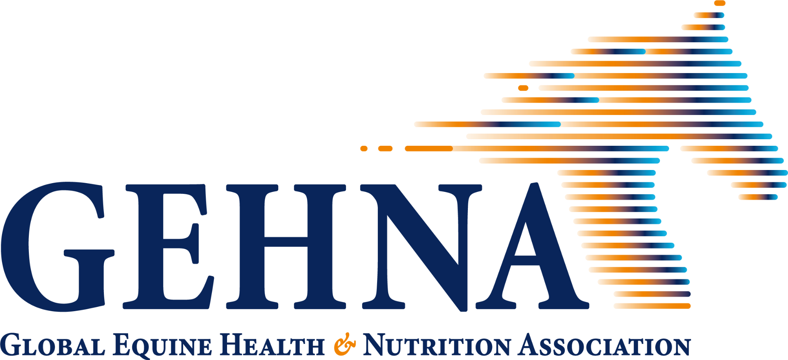Membership Packages
Package^{1,2} | Bronze^{1,2} | Silver | Gold | Diamond | Platinum^{1,2}
Annual Fee (€) | 850 | 2,500 | 5,000 | 7,500 | 10,000
Portal Access | ✔ | ✔ | ✔ | ✔ | ✔
Discounts | Basic | Moderate | Extended | Full | Moderate
Governance³ | — | ✓ (limited) | ✓ | ✓✓ | ✓
¹ Membership Scope: The Bronze package is reserved for single-person companies or independent nutrition consultants and includes limited governance rights. The Platinum package is designed as a group membership.
² Governance and Voting Rights: Governance participation is limited for Bronze members. Voting rights at the Annual Meeting are granted to Silver, Gold, Diamond, and Platinum members, with voting weights of 1 (Silver), 2 (Gold), 3 (Diamond), and 4 (Platinum). Platinum memberships are represented by a designated group representative who casts votes on behalf of all group members.

Package details

Platinum (€10,000/year; Group)
- Project results shared after completion of the project and report
- Access to the GEHNA University & Research Portal
- Discounts on other congresses & (Online) Education

Diamond (€7,500/year)
- Includes FRASC PRO access for 5 users for a full year (€750 value)
- 5 members receive 50% discount on congress fees
- Access to the GEHNA University & Research Portal
- Biannual updates on ongoing projects (2x per year)
- Discounts on other congresses & (Online) Education
Gold (€5,000/year)
- Includes 50 conversions on FRASC PLUS (€250 value)
- 3 members receive 40% discount on congress fees
- Access to the GEHNA University & Research Portal
- Annual updates on ongoing projects (1x per year)
- Discounts on other congresses & (Online) Education
Silver (€2,500/year)
- 1 member receives 30% discount on congress fees
- Project results shared after completion of the project and report
- Access to the GEHNA University & Research Portal
- Discounts on other congresses & (Online) Education

Bronze (€850/year)
- Project results shared after completion of the project and report
- Access to the GEHNA University & Research Portal
- Discounts on other congresses & (Online) Education

