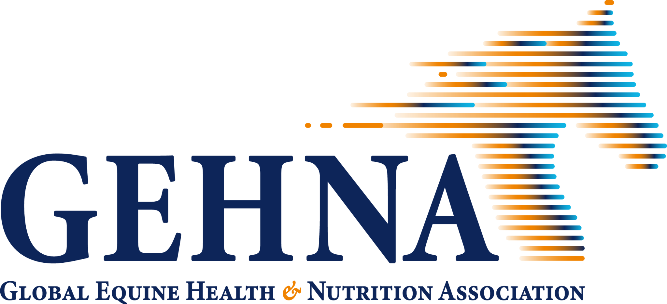
GEHNA Affiliative membership form
The mission of GEHNA
The Global Equine Health and Nutrition Association (GEHNA) aims to bridge the gap between global and regional equine health knowledge, initiatives, and perspectives. Our mission is to foster a collaborative environment that drives research, development, and alignment of practices across the equine industry worldwide.
Our Vision
Our vision is to establish a unified global standard for equine nutrition, optimizing the nutrition, health, care, and performance of horses worldwide.
GEHNA Membership Options
GEHNA offers an inclusive membership structure designed to bring together companies, researchers, and institutions across the global equine community.
GEHNA offers two types of memberships — Industry Memberships for companies and organizations active in the equine sector, and Affiliative Memberships for academic and research institutions contributing knowledge and expertise.
GEHNA Academic Affiliate Program
GEHNA provides a platform where researchers, educators, and industry partners come together to share data, harmonize methodologies, and translate scientific findings into real-world impact. By joining GEHNA as an Affiliative Member, your institution becomes part of a global network dedicated to setting and upholding the highest standards in equine nutrition and health. Joining GEHNA connects academia with industry, ensuring that research informs practice — and practice, in turn, inspires new avenues of discovery.
Membership is free to Academic Affiliates, with the provision of the required information in the application. This information will be used in our Shared Knowledge Portal.
About the Shared Knowledge Portal
As an affiliate member, an important benefit is being included in the Shared Knowledge Portal. The Shared Knowledge Portal is a central platform where academic affiliates can showcase their expertise, research facilities, and ongoing projects with GEHNA’s global network of industry partners.
By providing information about yourself, your research program, and your facilities, you are enabling GEHNA to:
- Increase your visibility and collaboration opportunities. GEHNA can identify researchers and programs with expertise required for applied research projects, funding opportunities, and collaborative workshops and forums.
- Support students and early-career researchers. Sharing information about your graduate students can help connect emerging young scientists with professional opportunities, mentorship, and recognition in the equine industry.
GEHNA will use the information you provide solely for the purposes of professional networking, collaboration, and promotion of your research within our membership. Contact information and student details will only be displayed with permission.
Benefits for Academic Affiliates:
- Free Meeting Registration: Attend the annual GEHNA meeting for free
- Discounted Conference Registration: Register for the Kentucky Equine Research Equine Health and Nutrition Conference and the European Equine Health and Nutrition Conference (EEHNC) at a discounted rate
- Collaborative Research Opportunities: Connect with industry and academic partners across the globe to pursue impactful, cross-disciplinary projects.
- Global Knowledge Exchange: Participate in working groups and discussions that shape best practices and drive innovation in equine health and nutrition.
- Visibility and Recognition: Highlight your institution’s research and expertise through the Shared Knowledge Portal and GEHNA meeting.
- Access to Industry Insights: Gain early awareness of emerging trends, challenges, and opportunities within the global equine sector.
- Influence on Global Standards: Contribute your expertise to the development of unified, evidence-based approaches to equine nutrition and welfare.
By providing the information below, you not only receive free membership to GEHNA, but you are also helping to bridge the gap between science and industry, contributing to the optimal health of horses worldwide.
Please provide the following information to become an Academic Affiliate member of GEHNA and to be included in the Shared Knowledge Portal.

ACADEMIC AFFILIATE APPLICATION
Required information:
Name and title (this person is the main contact responsible for the research group):
Email address:
Phone number: (For admin purposes only, will not be shared in Portal)
University:
Faculty:
Department:
Research Group (if individual is part of a larger group):
Researcher / Group expertise areas:
Brief description of your research program (250 words or less):
Upload a picture of yourself for your profile.
Upload a university or department logo that you would like associated with your profile. Please ensure that the university standards on logo use and quality are being met.
Fill out the following, as applicable:
ResearchGate profile:
Personal and/or Research Group LinkedIn profile:
ORCID ID:
List up to 15 select research publications (if links to ResearchGate or Orcid are not available):
Link to your research group’s website:
Description of research animal facilities. Should include description of animal population, animal housing, animal research equipment (e.g., treadmill, hot walker, livestock scale, etc).
Description of laboratory facilities. Should include a list of analytical capabilities:
List up to 15 popular press articles:
List professional organizations you belong to:
List typical conferences you like to attend:
List of current projects with the following information: Graduate student (with permission from student; see below question), project supervisor (if there are more than one in the research group)
If graduate student gives permission to be included, please provide the following information for each student: Name, Degree Program (Master's or Ph.D.), Hometown, Previous Degree(s), Research Project Title or Area of Study, Expected Graduation Date, Future Career Goals, [optional link to LinkedIn or email address]

- I am interested in being contacted about collaborative research projects with industry members.

